AI ASSISTED CODING

ASSIGNMENT -4.1

HALL TICKET NO : 2403A52400
BATCH NO : 14
TASK_1 –
CODES WITH OUTPUT
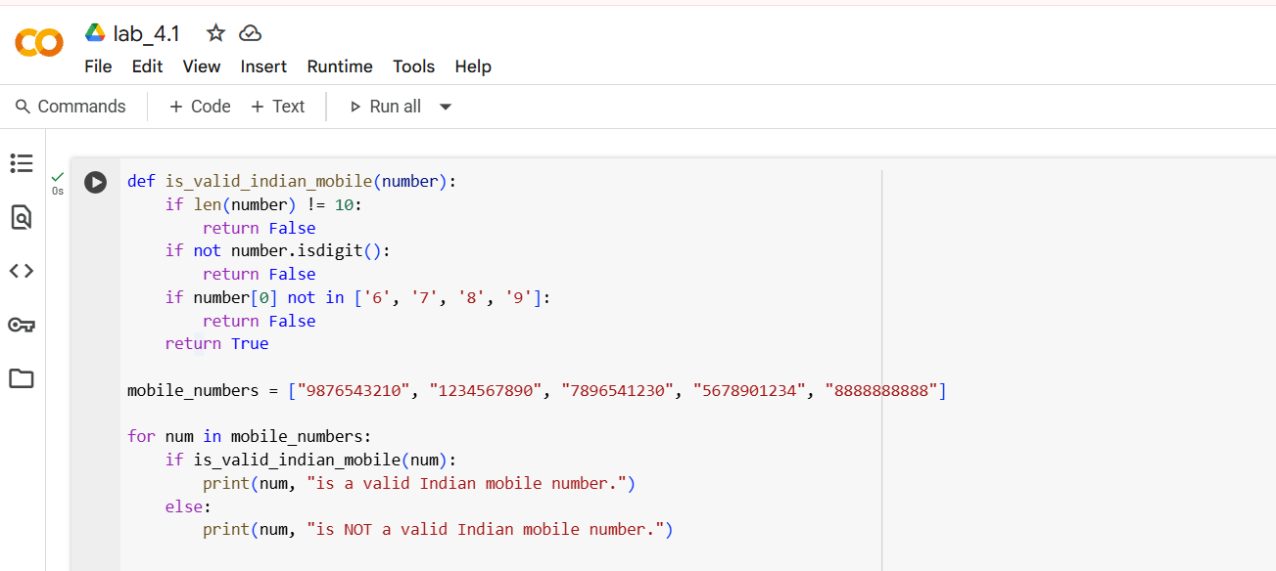
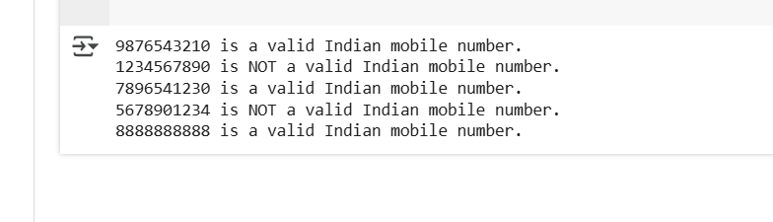
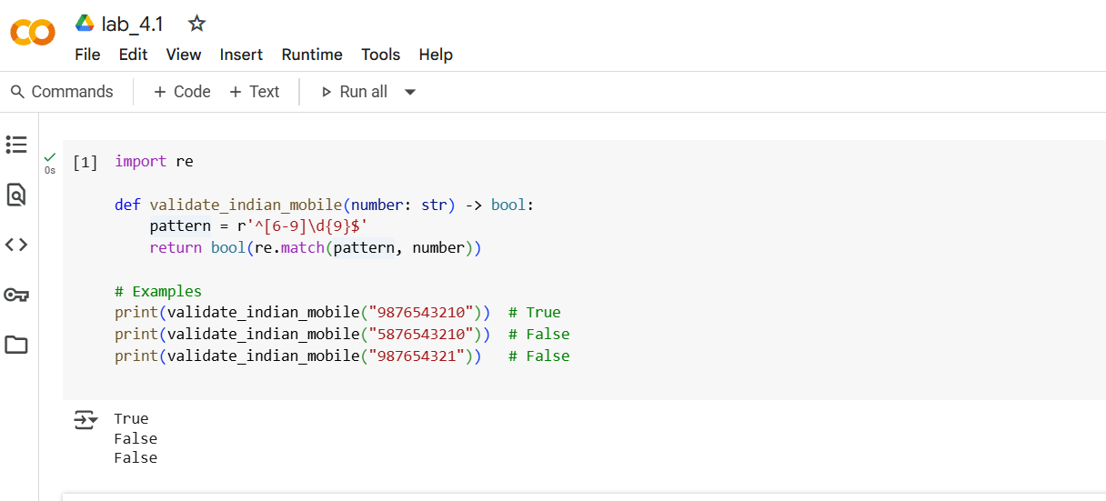
EXPLANATION OF THE CODE
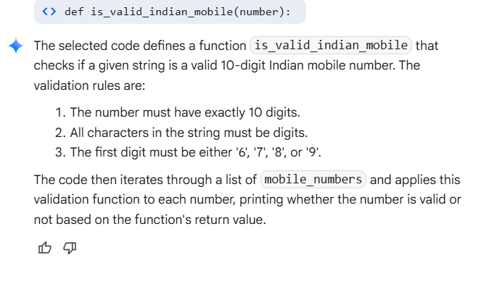
TASK_2 –
CODE WITH OUTPUT
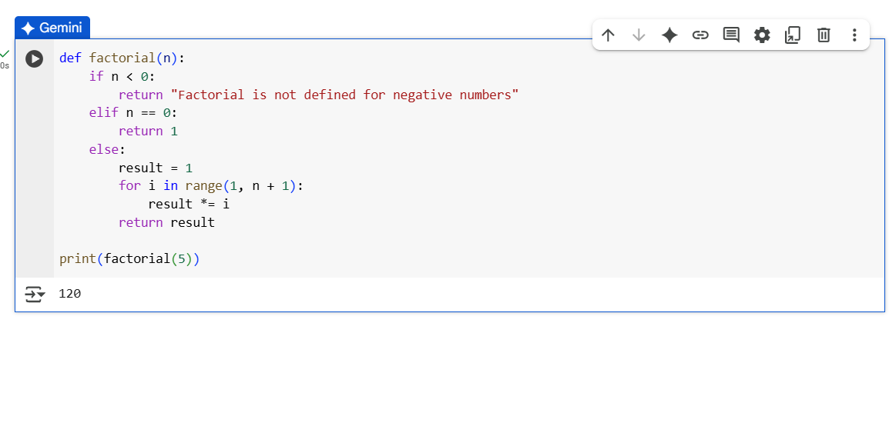
EXPLANATION OF THE CODE

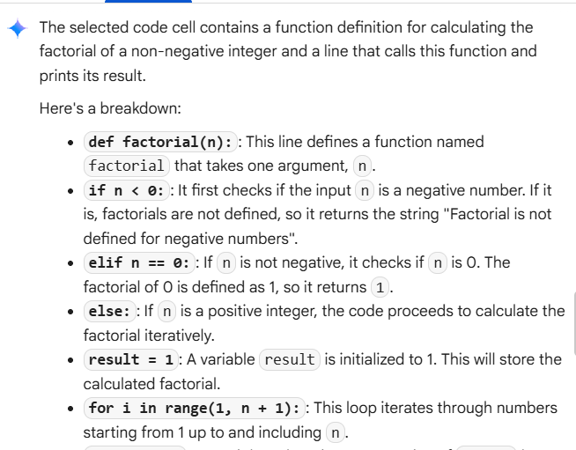
TASK_3 –
CODE WITH OUTPUT
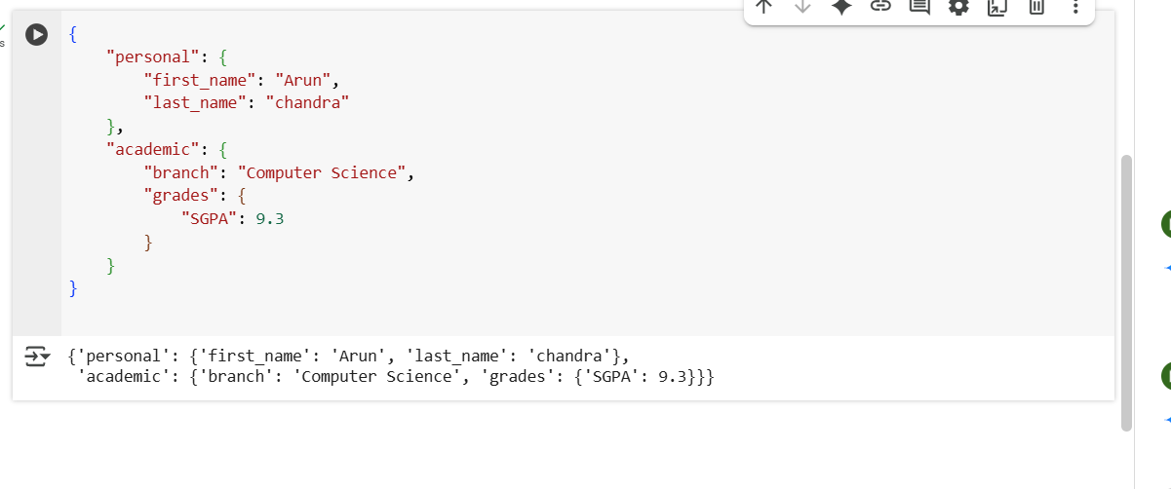
EXPLANATION OF CODE
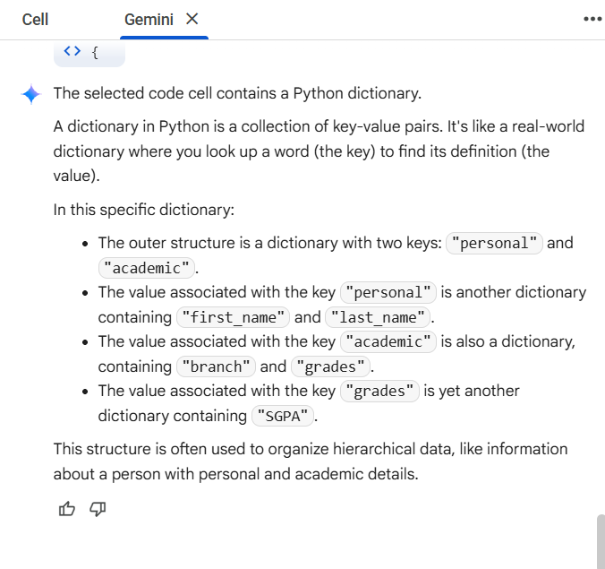
TASK_4 –
Experiment with zero-shot, one-shot, and few-shot prompting to generate functions for CSV file analysis.
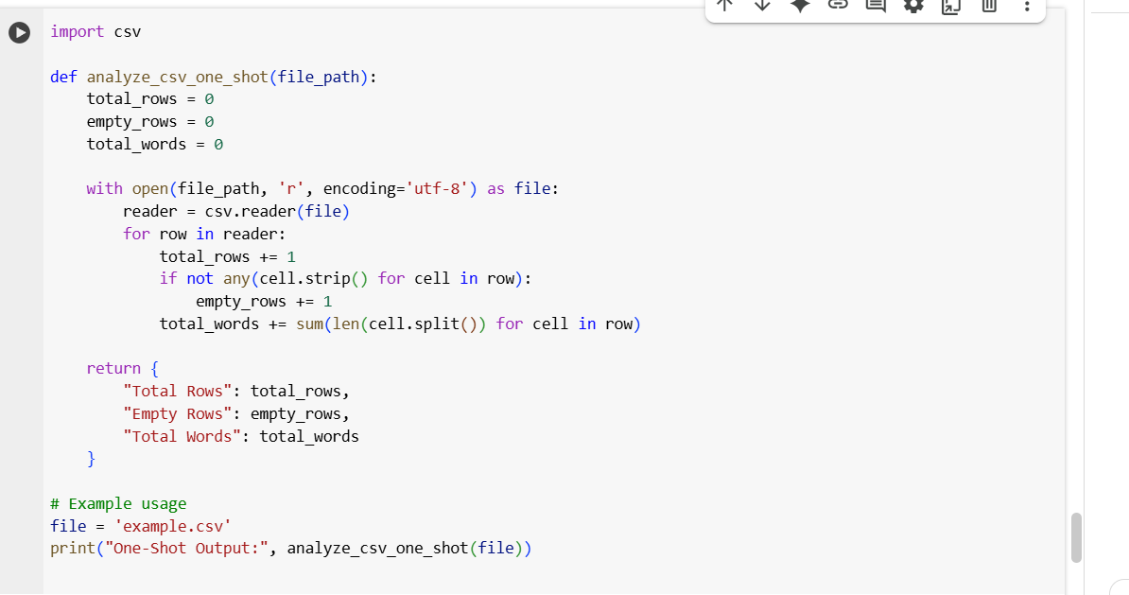
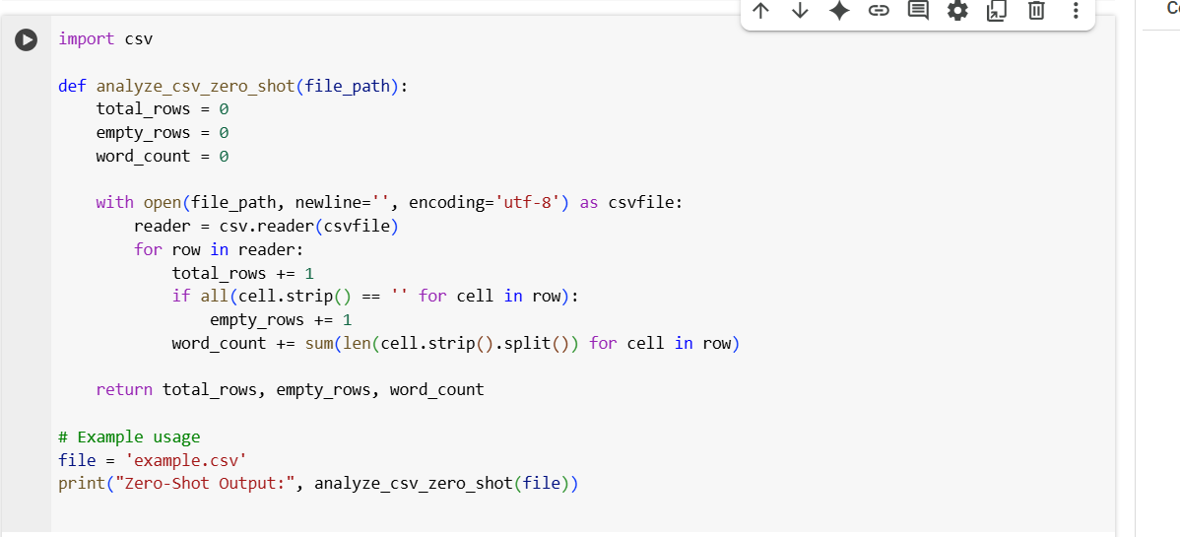

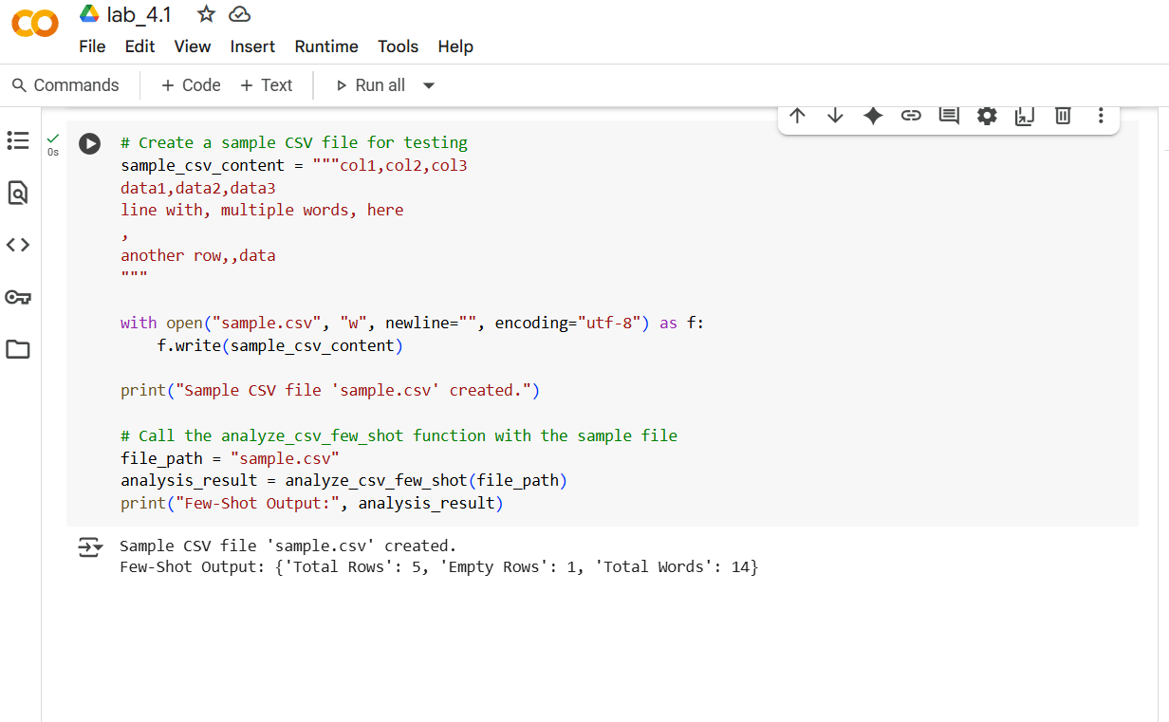
EXPLANTION OF THE CODE
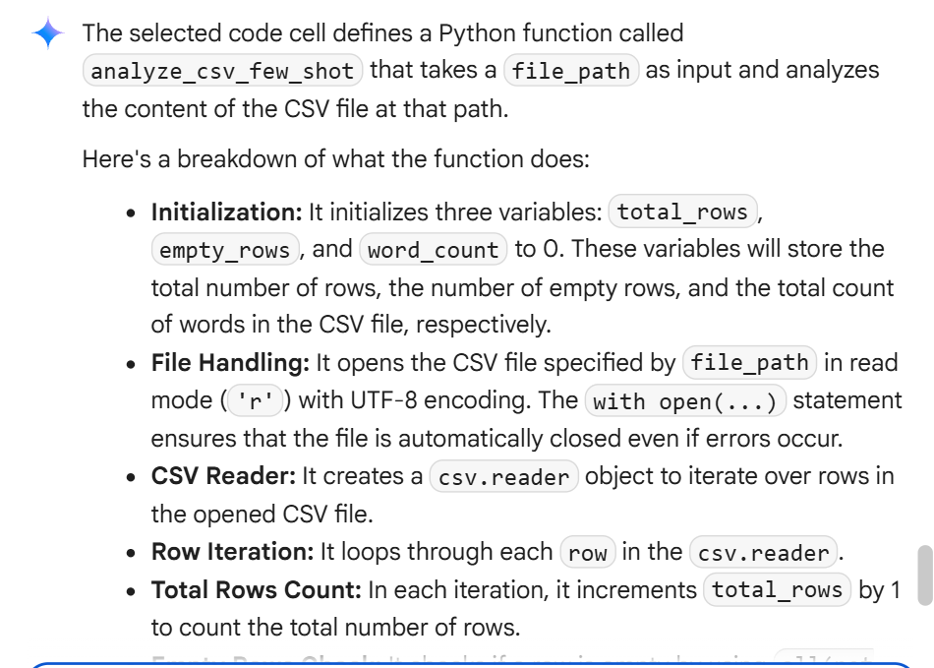
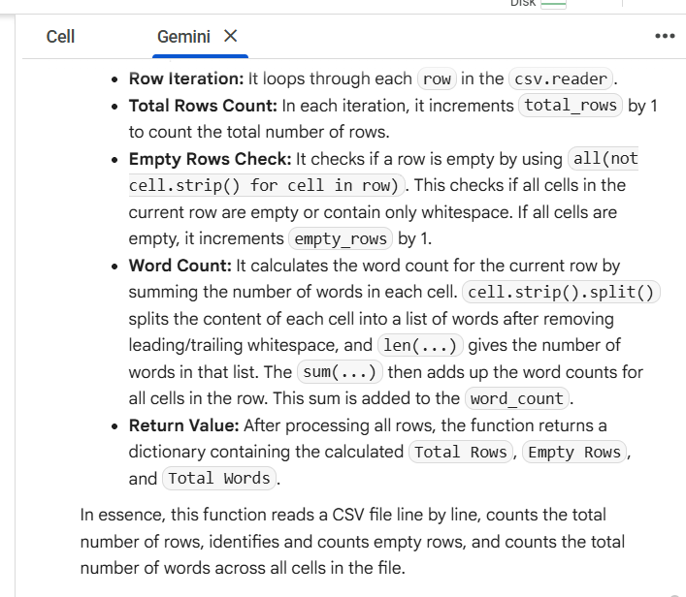
TASK_5 –
CODE AND OUTPUT